**Log Data Preparation**

1. Baseline (Run full 693k rows)

2. Tune Model LGBM (Run full 693k rows)

3. Tune Model LGBM to all hyperparameter except learning_rate (Run full 693k rows)

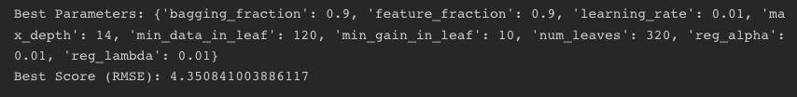

Sepertinya harusnya basemodel pakai jumlah data yg sama

7. Tune Model LGBM for learning_rate (Run 69,3k rows)

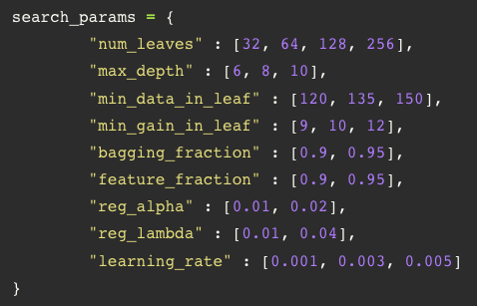

8. Tune Model LGBM for learning_rate (Run 69,3k rows)

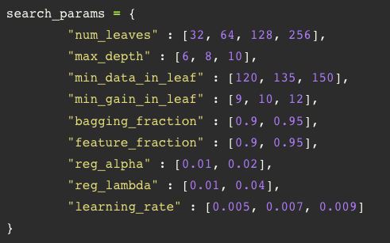

9. Tune Model LGBM for learning_rate (Run 69,3k rows)

10. Tune Model LGBM for learning_rate (Run 69,3k rows)

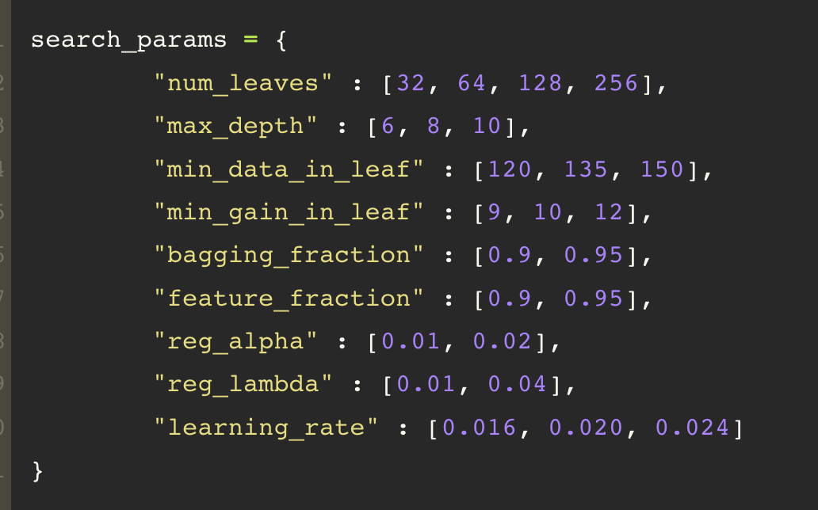



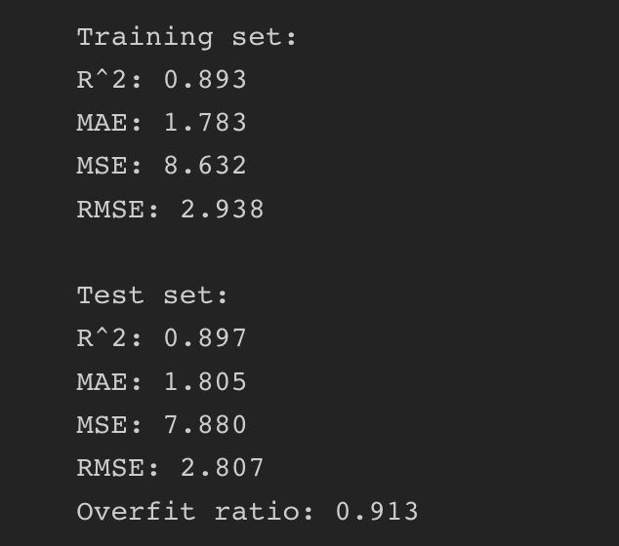

11. Tune Model LGBM for learning_rate (Run 6,93k rows)

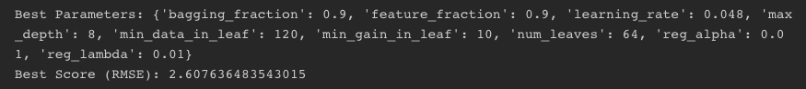

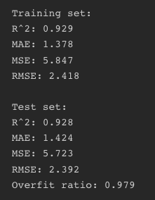

12. Tune Model LGBM for learning_rate (Run 6,93k rows)

13. Tune Model LGBM for learning_rate (Run 6,93k rows)

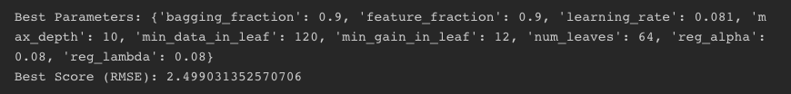

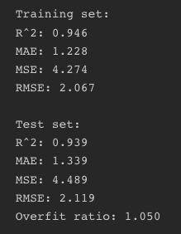

14. Tune Model LGBM for learning_rate (Run full 693k rows)



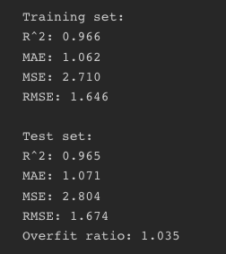

15. Tune Model LGBM for learning_rate (Run full 693k rows)

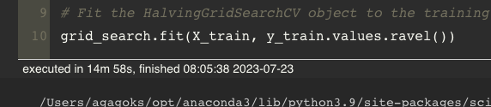

16. Tune Model LGBM for learning_rate (Run full 693k rows)

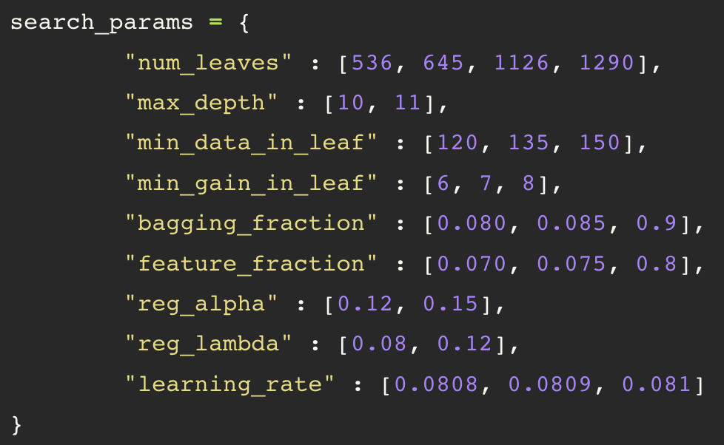

17. Tune Model LGBM for learning_rate (Run full 693k rows)

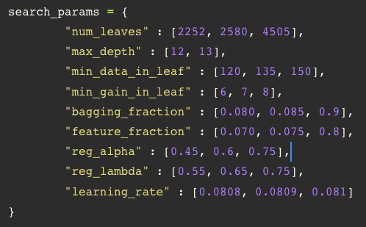



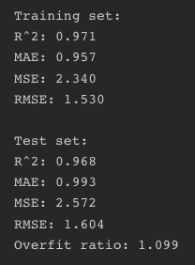

18. Tune Model LGBM for learning_rate (Run full 693k rows)

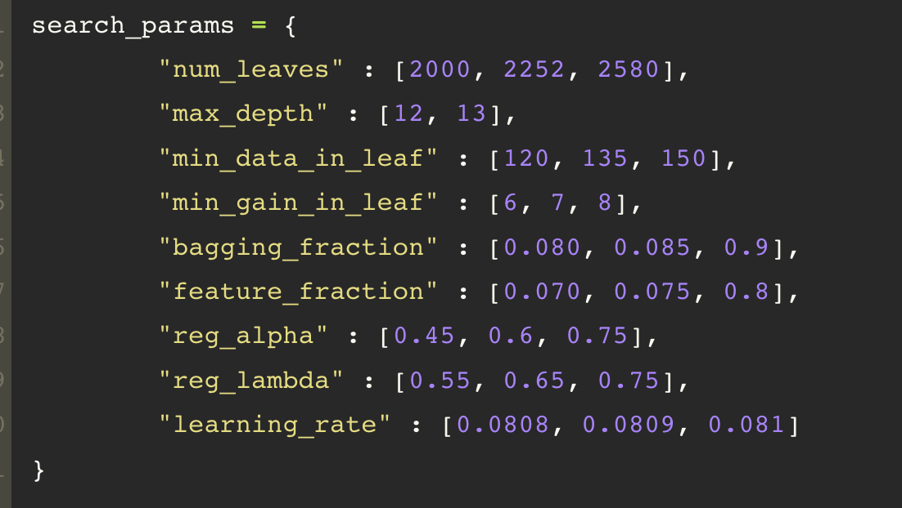

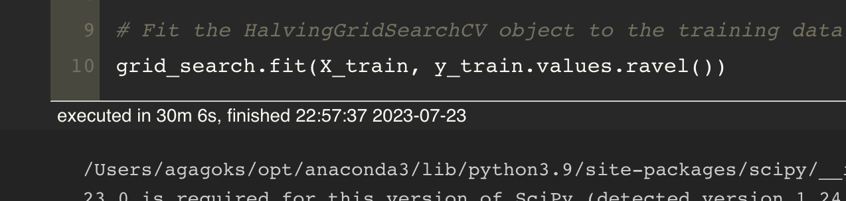



19. Tune Model LGBM for learning_rate (Run full 693k rows)

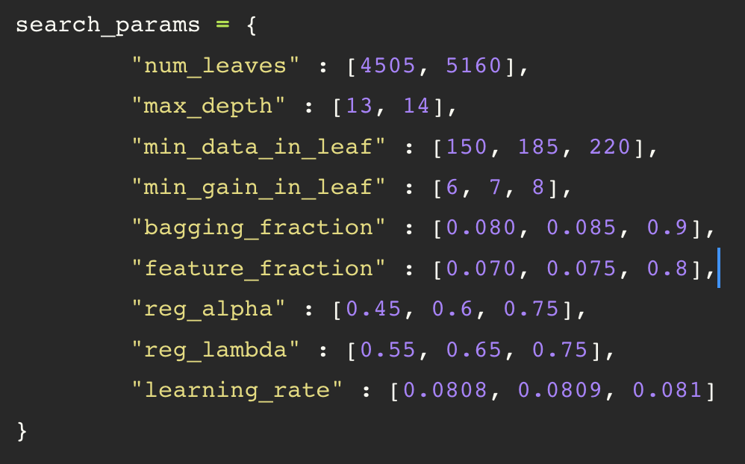

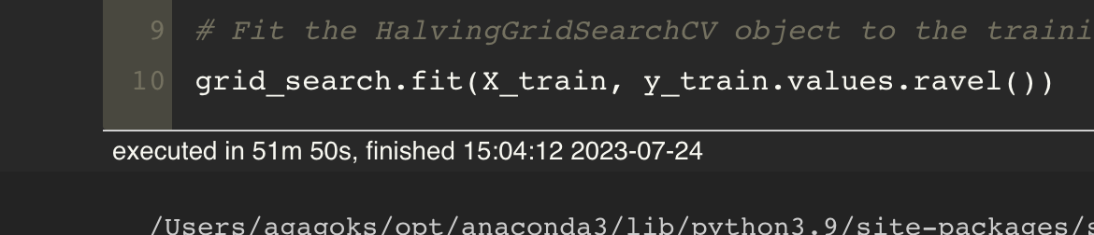



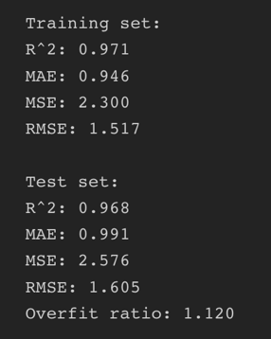

20. Tune Model LGBM for learning_rate (Run full 693k rows)



